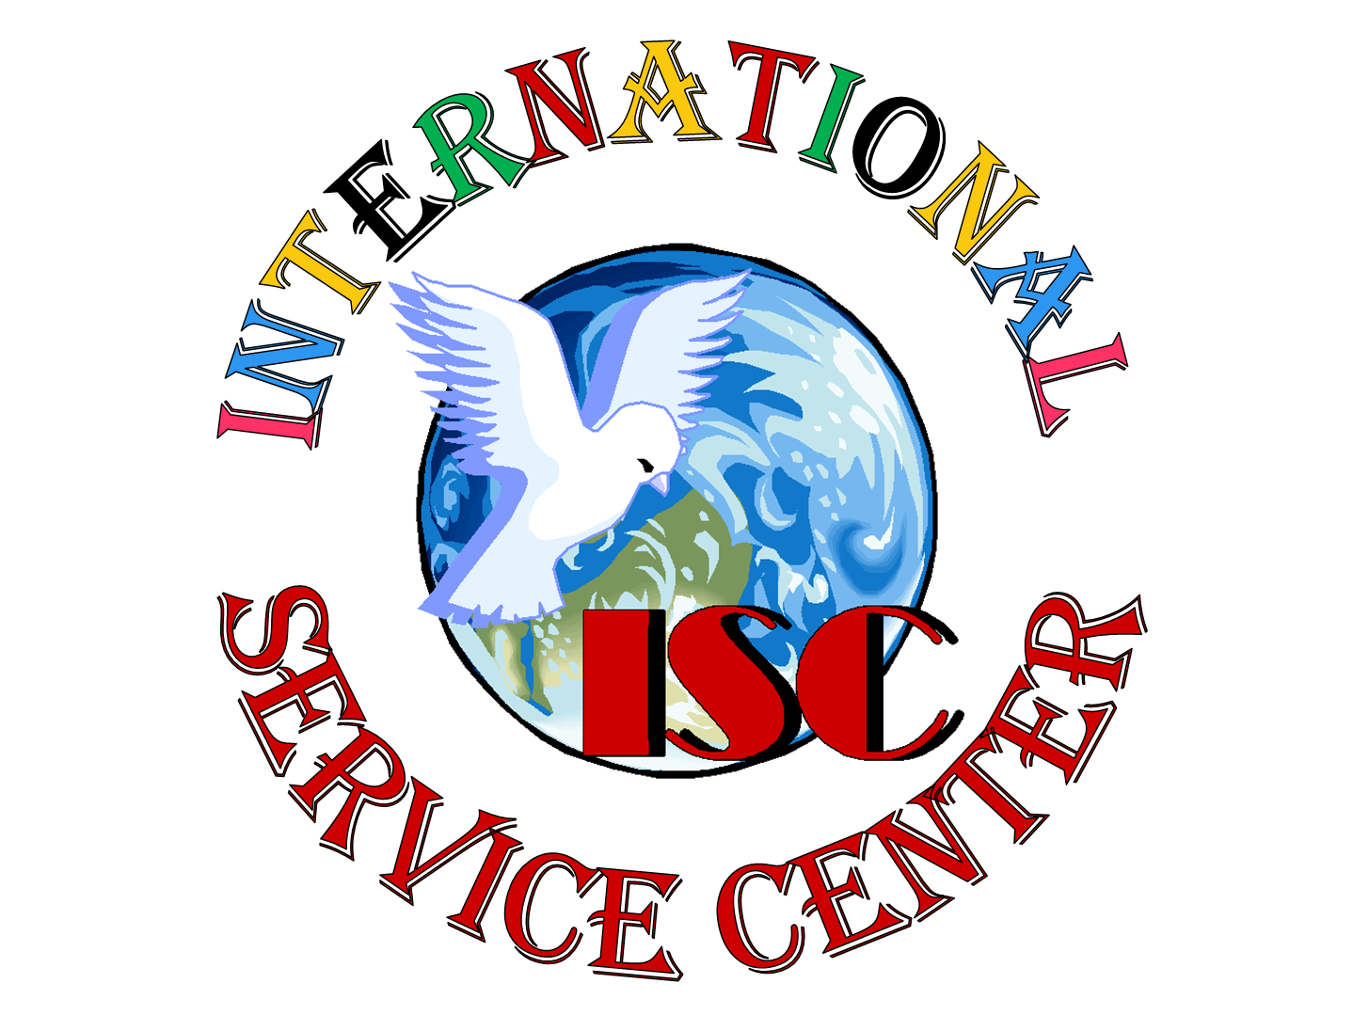
ISC's Overseas Mission in Gambia
Donated medical supplies to Basse Community Health Center, in Gambia (West Africa)
Last summer, thanks to a group of wonderful Good Samaritans from U-Penn School of Medicine in Philadelphia, our Program Assistant, Sailey Sey, was able to bring back much needed medical supplies to her hometown of Basse in Gambia. Sailey delivered the donated medical supplies, which include Dry Suction Chest Drain, Lubricating Jelly, Urethral Stent Set and other general hygiene items, to the Basse Community Health Center. The impoverished inhabitants who are living in over 100 deprived villages surrounding this unique community health center are the fortunate beneficiaries of this remarkable generosity from U-Penn School of Medicine's donors.

